ZMK Key Changing Tutorial
- Introduction
The keymap changing method for ZMK keyboard can currently only be achieved by compiling new firmware. The ZMK button modification software is expected to take another six months to complete. The simplest way to modify keys now is to use the GitHub website to generate new firmware, and then flash it into the keyboard. So this article focuses on two parts: how to flash firmware into the keyboard and how to generate the new firmware you need.

- How to flash firmware into the keyboard
Whether it's the new version of Corne, Sofle, or other ZMK keyboards, the keyboard is connected to the computer by USB, and then double-click the RESET key to enter BootLoader mode. At this point, you can see a new USB flash disk named nice！Nano. We just need to put the new firmware into the first layer directory of this USB drive. Do not delete any files from the USB drive. Of course, the way to enter BootLoader can also be by triggering the &BootLoader keycode through a combination of keys. After modifying the keymap, you can get new frimware .In most cases，only need to flash the left_hand keyboard（mian keyboard）. Updating firmware for the keyboard also need connecting a USB cable.
The setting_reset firmware’function is to clear the connection configuration of the left and right keyboards.

- How to generate the new firmware as you need
The keyboard has many functions that can be modified. I suggest understanding the functions of the keyboard before modifying the firmware. You should first take the time to understand the existing functions of the keyboard and familiarize yourself with the characteristics of keyboard operation. Afterwards, summarize your modification requirements for the original functions. There are many ways to create ZMK keyboard firmware, such as installing the ZMK compilation environment locally and using GitHub's codespace. I recommend the simplest method, which is to use the git action feature on GitHub to compile new firmware.

- Visit the official GitHub website and register an account

- Click on the link I provided (GitHub repository), as mentioned earlier, the keyboard configuration is different, so the repository is not completely universal. Of course, if you are just a corne without backlight and screen, many configuration libraries can be used interchangeably. But almost all of the keyboards I sell have special peripheral added, so they are destined to be incompatible with other people's repository. So please make sure which one repository you need. Do not use other people's configuration libraries .
Eyelash-corne https://github.com/a741725193/zmk-new_corne
eyelash-Sofle https://github.com/a741725193/zmk-sofle
Sofle-dongle https://github.com/a741725193/zmk-sofle-dongle
Corne-dongle https://github.com/a741725193/zmk-corne-dongle
Eyelash-Corne-OLED https://github.com/a741725193/zmk-corne-oled
Eyelash-sofle-OLED https://github.com/a741725193/zmk-sofle-oled
OLED-sofle-DONGLE https://github.com/tokyo2006/zmk-solfe-dongle
OLED-corne-DONGLE https://github.com/tokyo2006/zmk-corne-dongle

The low profile corne and sofle use the github repo as same as mx version.

- How to use the GitHub repository provided by the seller.

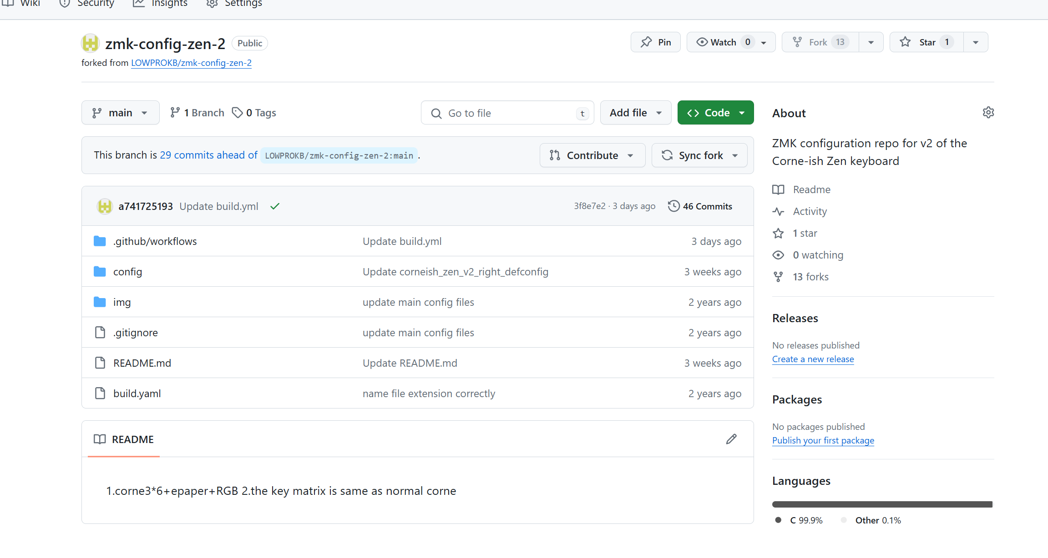
In the above interface, click on "fork" in the upper right corner to create your own branch repository. After clicking fork, the following interface will appear

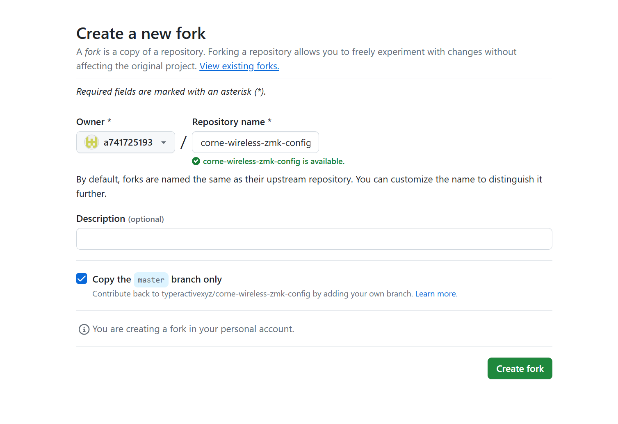
In the above interface, you can modify the name of the repository or not, and the description below is like a note that can be added . So the simplest way is to directly click the green button “create fork”. After clicking, a new page will appear to refresh, and the following interface will appear, with the same content as the referenced repository.
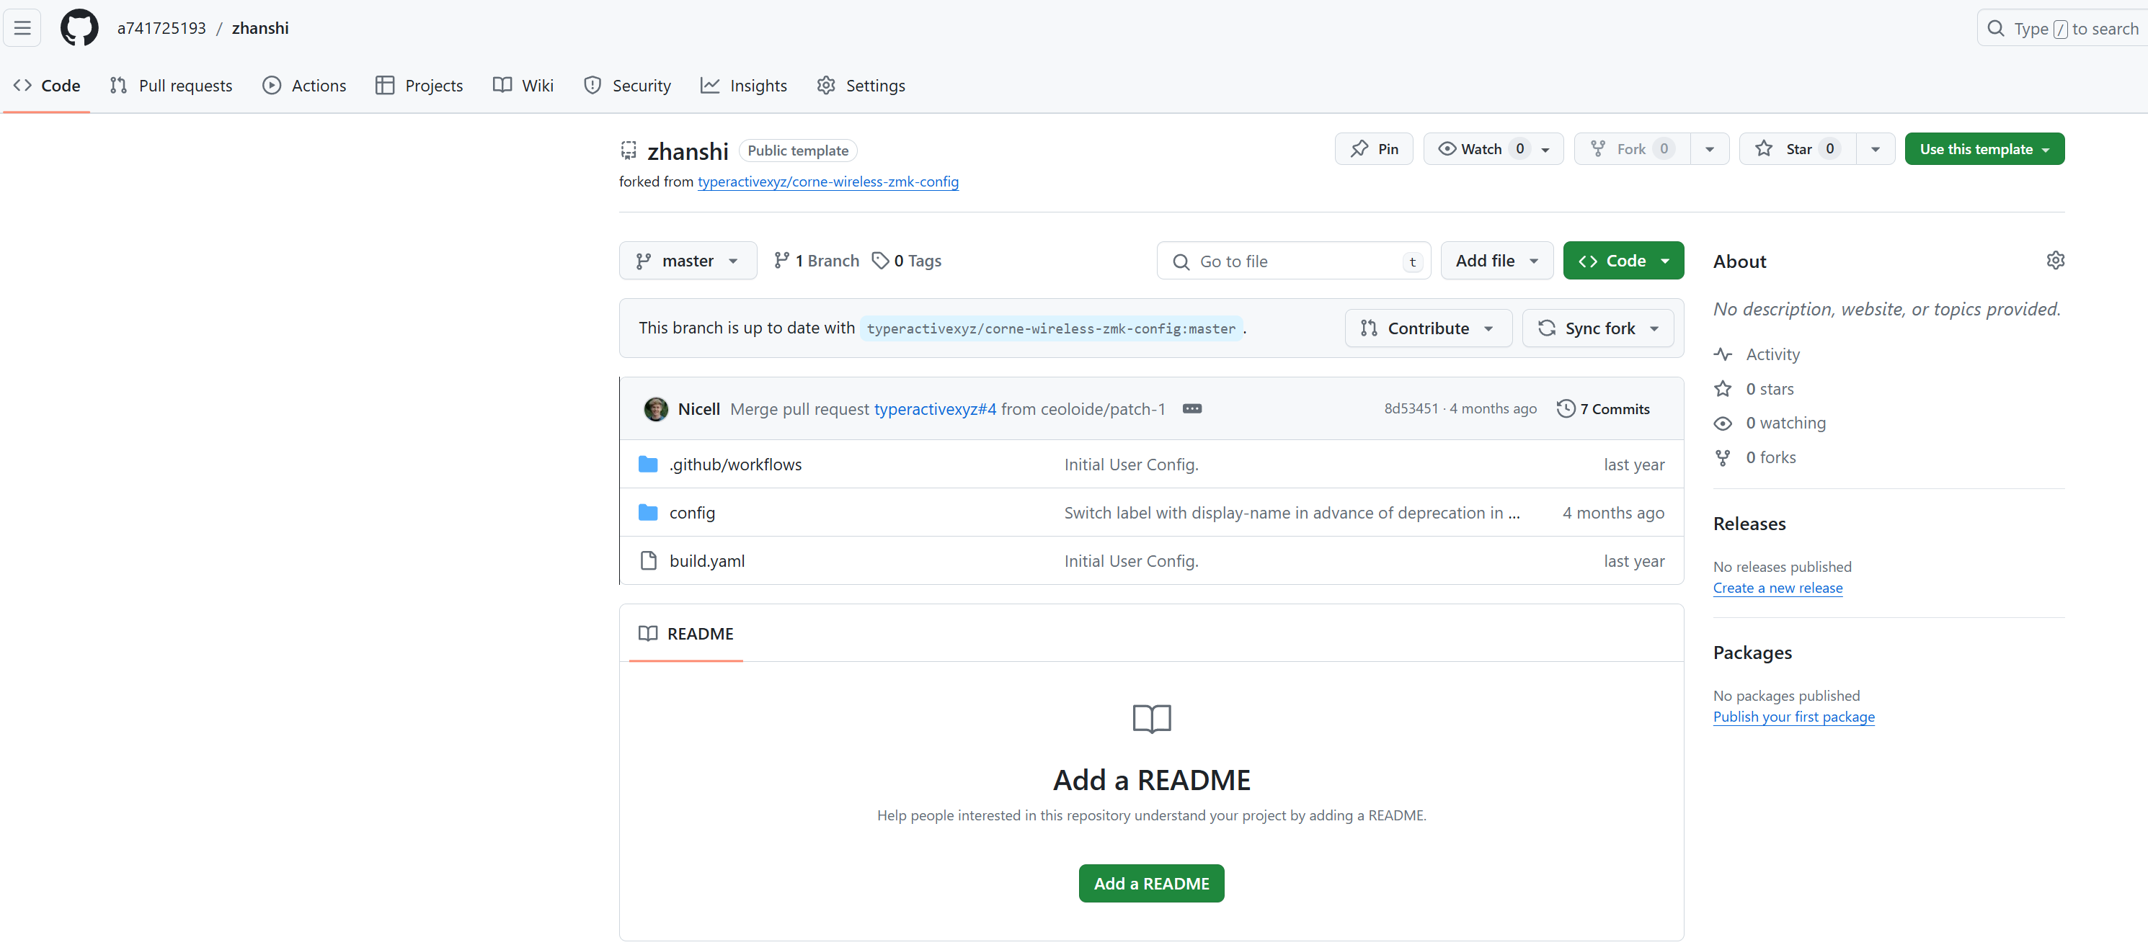
Now click the “action”,into a new page.

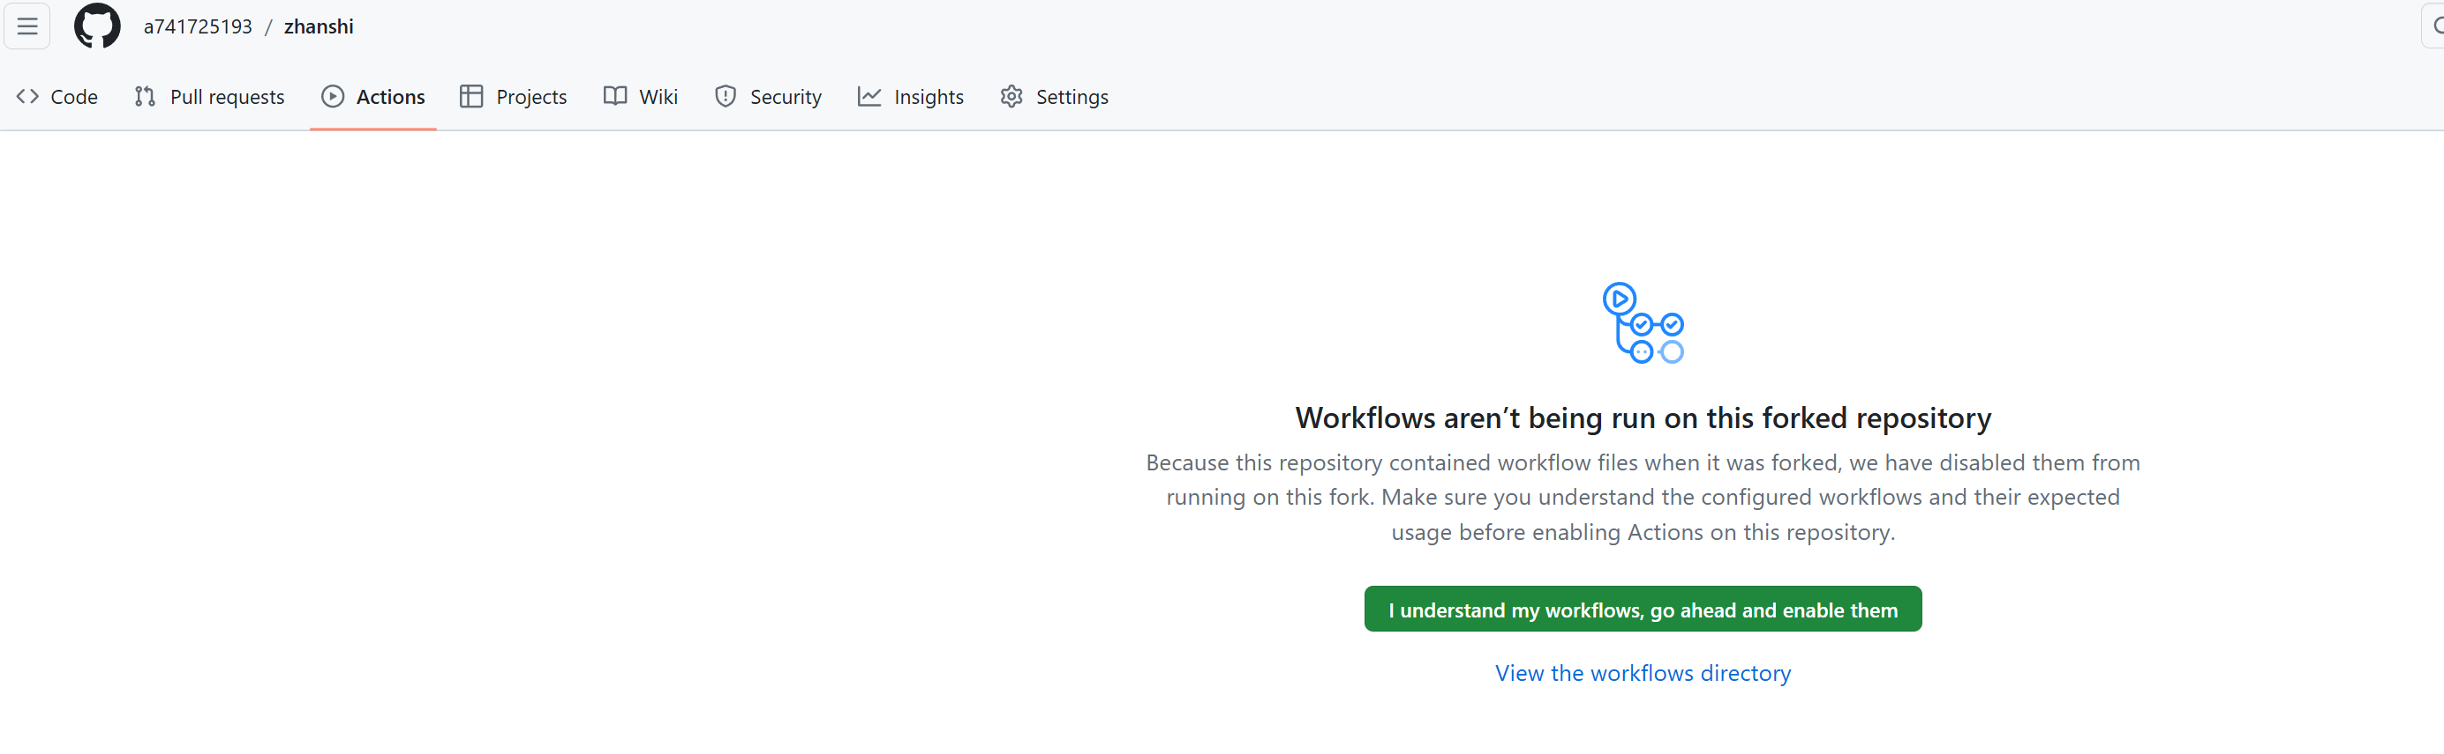
Click the “I understand workflows,go ahead and enable them”

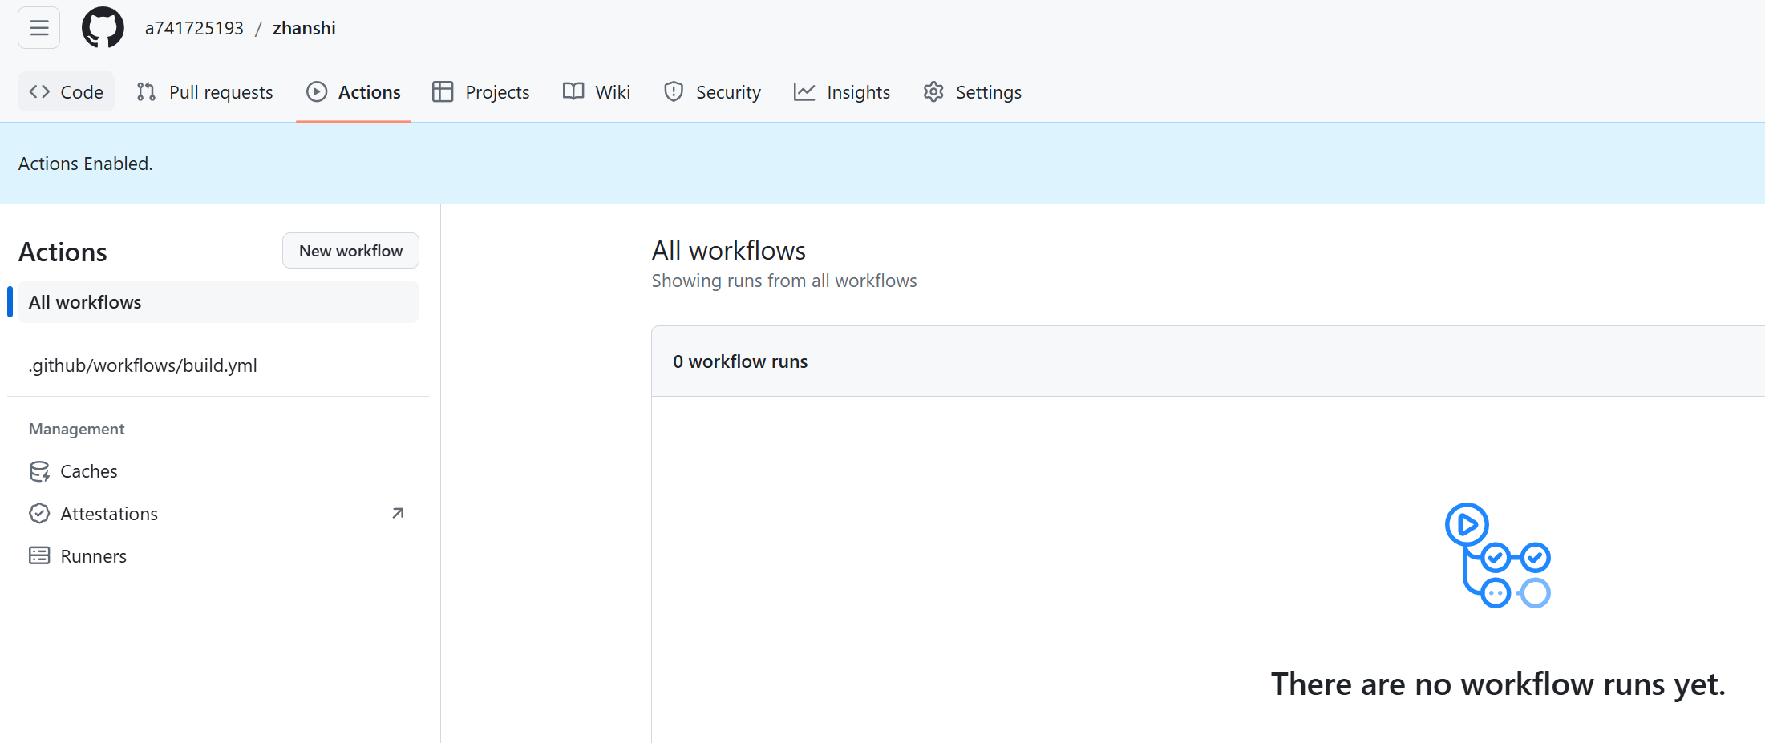

In the above picture, click on the option bar on the left. github/workflow/guil.yml

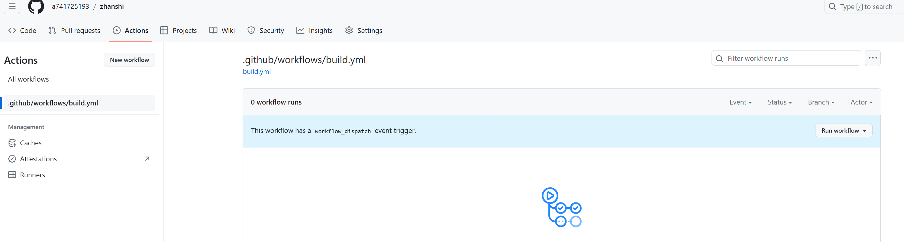
Click the “run workflow”botton

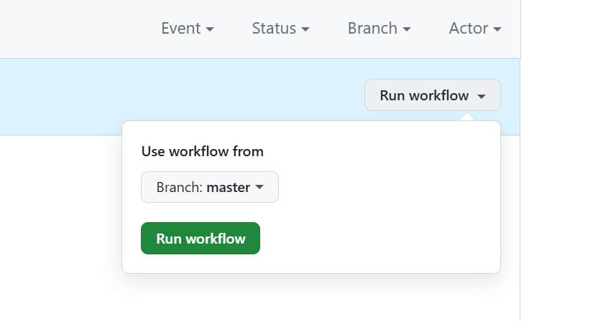
Click the Run workflow

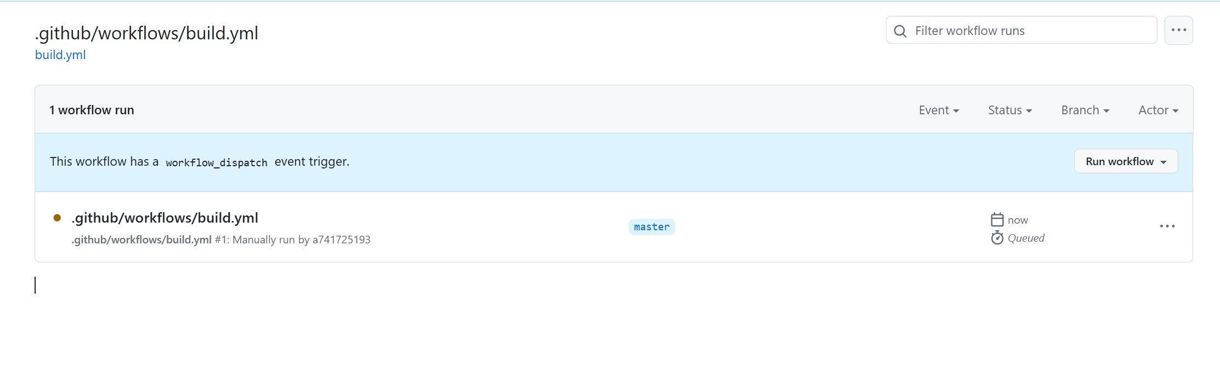
The page content will refresh to look like the image above, with yellow dots indicating that the firmware is being compiled. Please wait patiently for about 10 minutes.

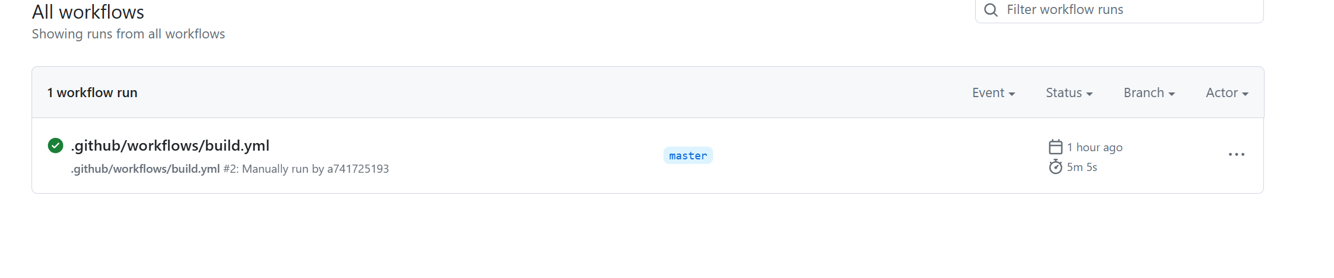
Turning green to √ indicates that the compilation has been completed. Then click on this GitHub/workflows/build. yml, and the following page will be displayed.

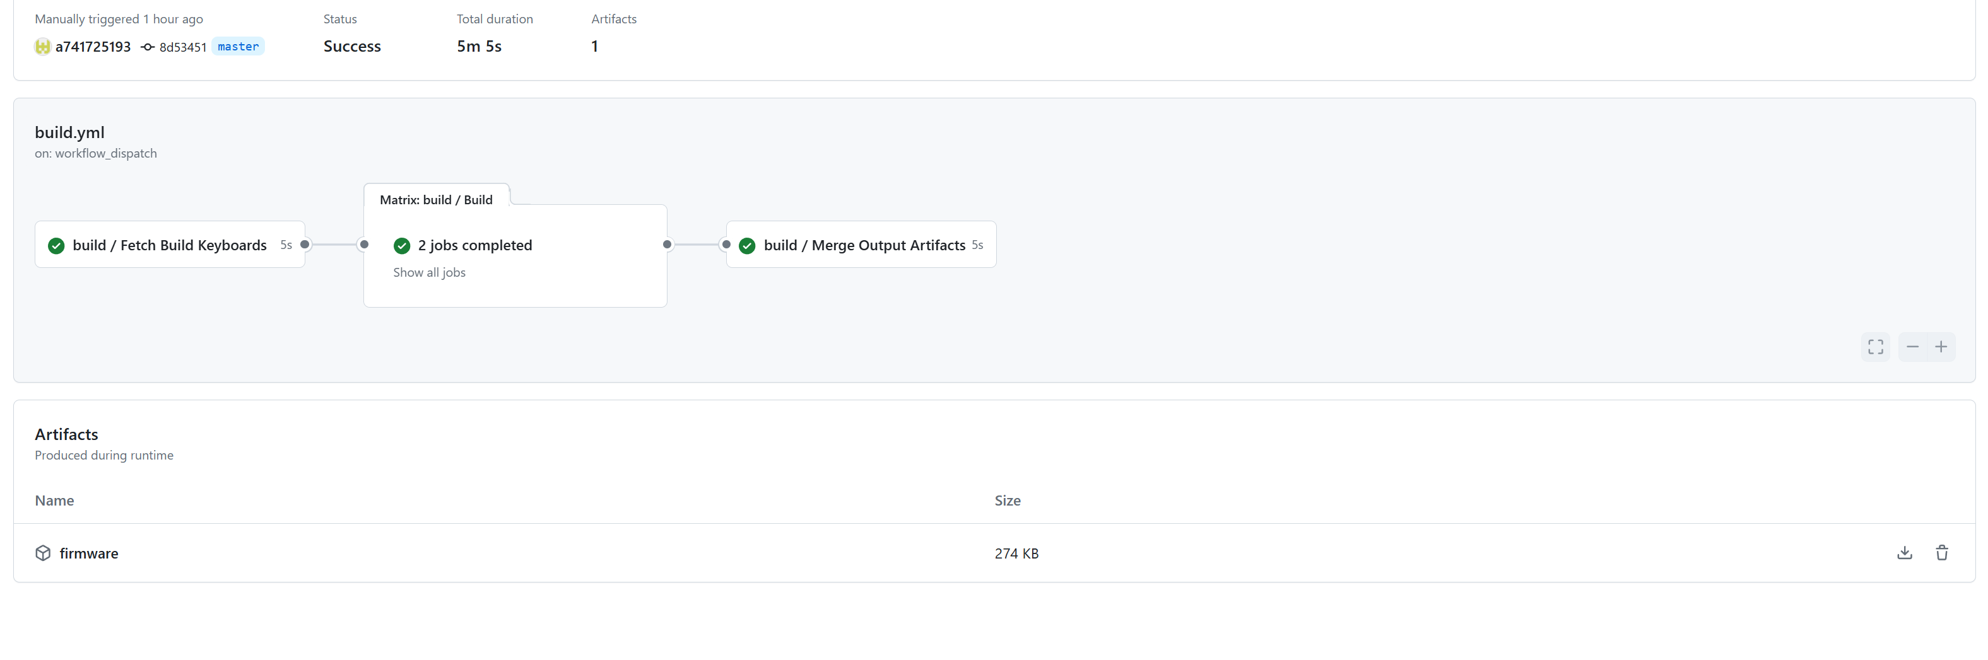
Click on the download icon in the bottom right corner of the above image to download the newly compiled firmware compressed file and decompress it. The files in the folder are the left and right hand firmware.

- How to burn firmware into the ZMK keyboard, the operating principle of other keyboards is the same. Insert the USB into the keyboard and press the reset button twice within 0.5 seconds. The USB drive letter appears on my computer and the new firmware is thrown in. Wait for the update to complete.After flashing the new firmware on the left and right keyboards, if there is power supply, they will automatically pair.

How to modify keymap
- Open the project repository you forked. Find the keyboardname.keymap file, enter and modify it.The location is project name → config folder → keyboardnano.keymap.You can directly modify the key code in the file, or use a third-party graphical tool to modify it. The name of this tool is Keymap Editor.The website is: https://nickcoutsos.github.io/keymap-editor/.Later, we will specifically introduce how to use this keyboard editor
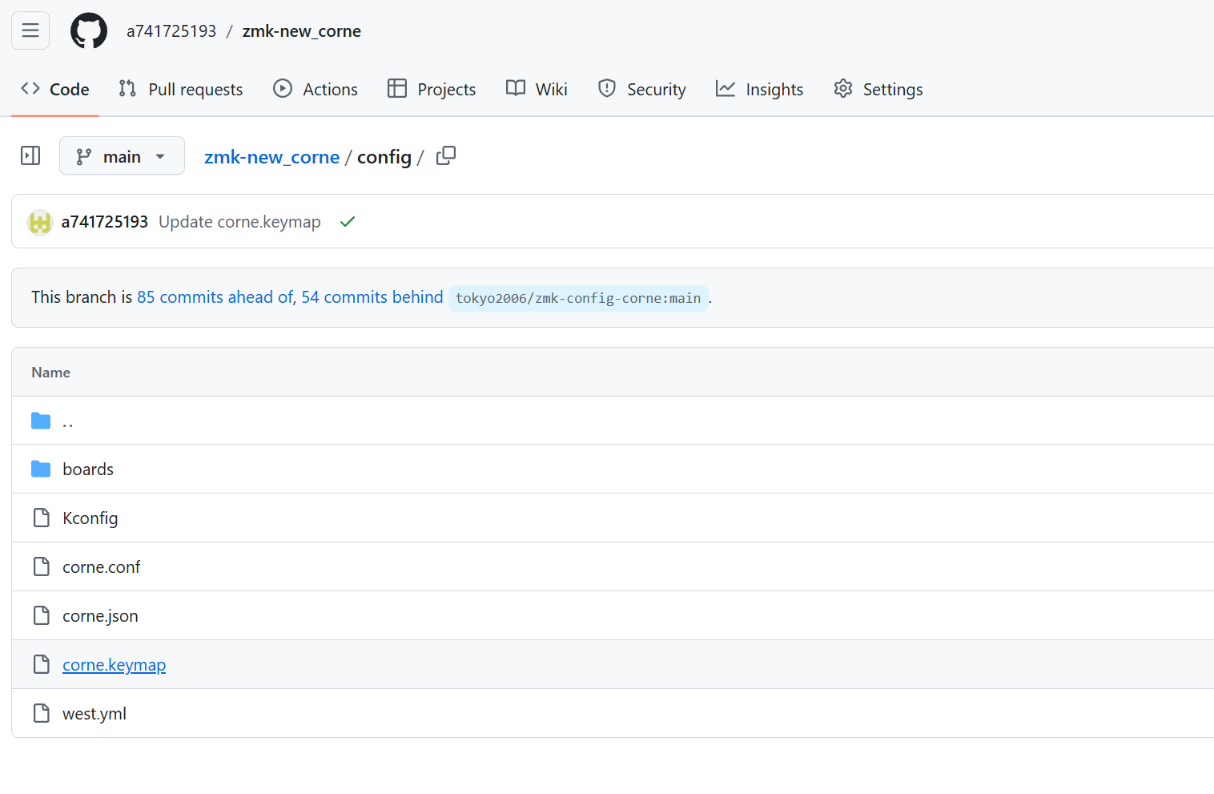
Enter the keyboardnano.keymap file

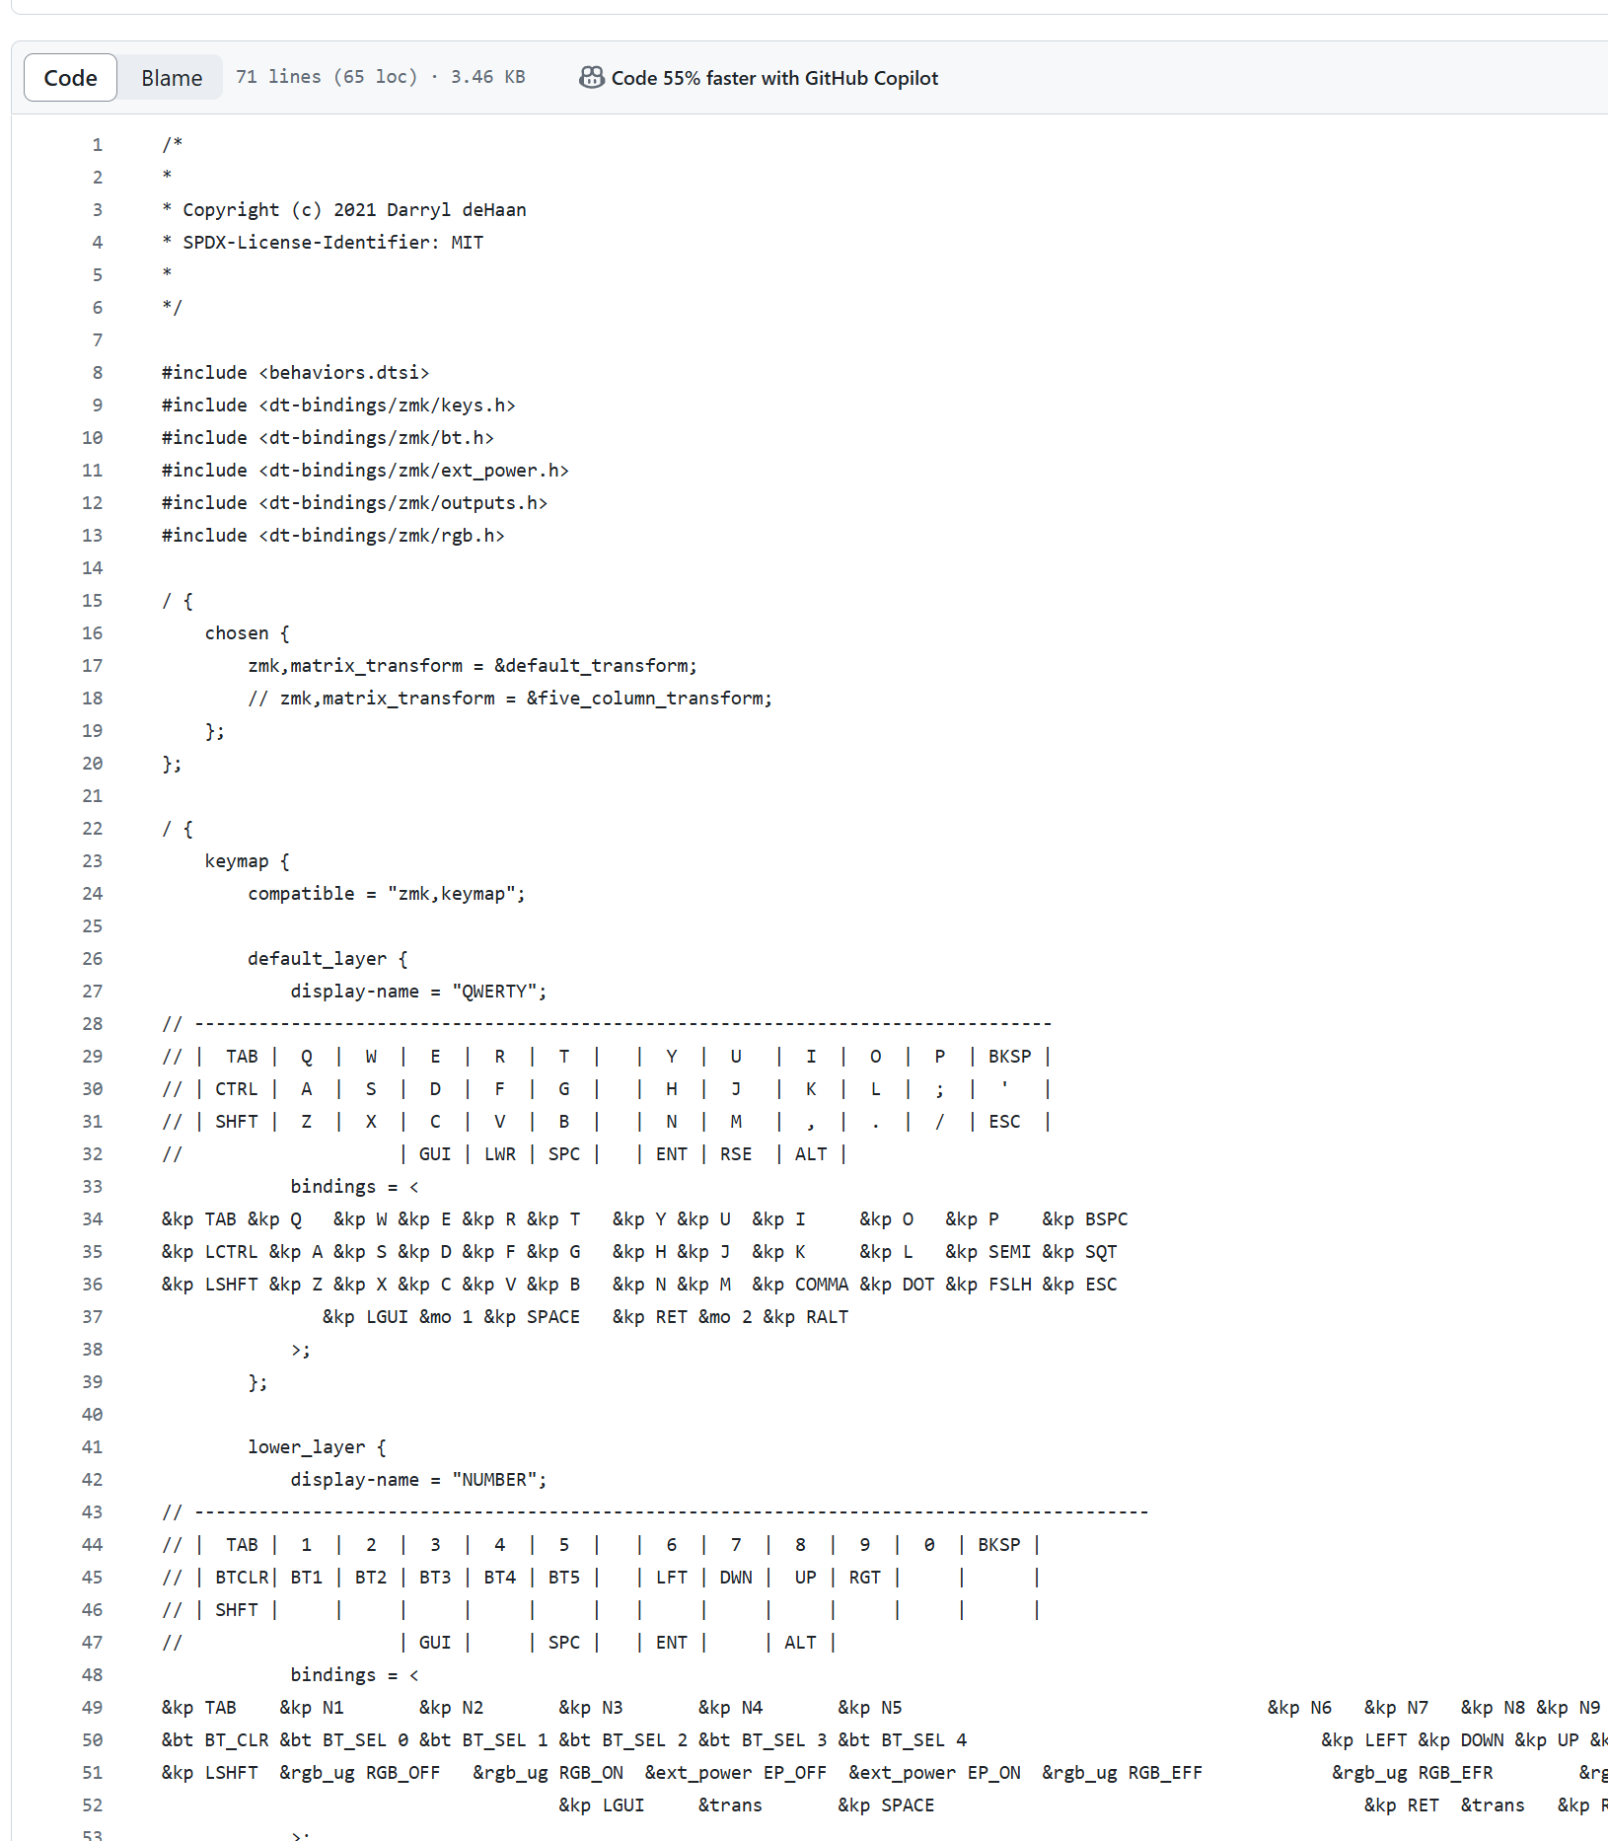
You can clearly see the default state key function diagram of your keyboard here. If you need to change the functions of two buttons, simply copy and paste them.“&trans”meaning it can be passed across layers. That is, the button function of this layer is the same as the previous layer. If certain key codes are deleted, you can check the original warehouse I provided or the ZMK official website.
https://zmk.dev/docs/codes/keyboard-keypad
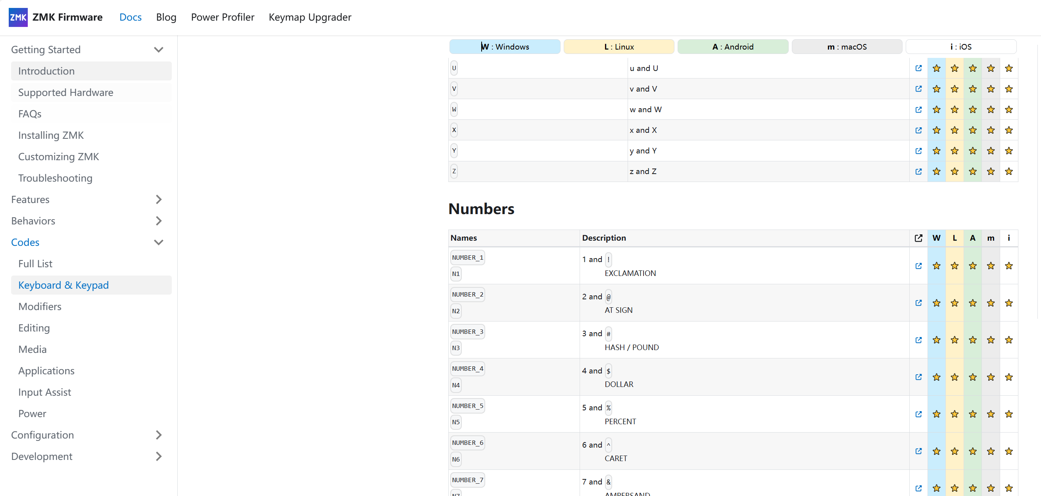
The left character in the above figure is the ZMK recognizable code, and the actual key value on the right side. Use requires adding&kp and a space.

Before making modifications, you need to click on the pencil icon in the upper right corner of the keymap page.
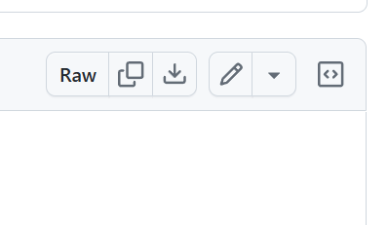
After the modification is completed, you need to click the green icon to“commit changes” .
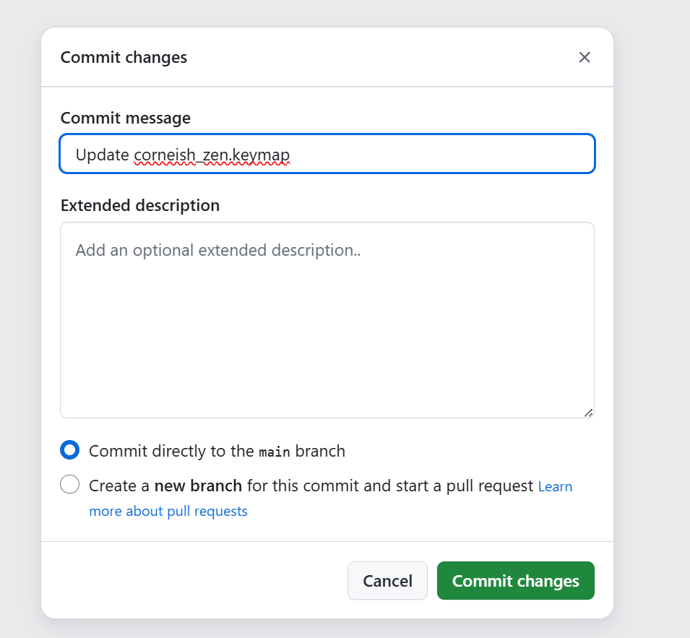
Afterwards, a confirmation menu will be displayed. Continue clicking on commit changes
After modification, git action will automatically trigger compilation. Click on the action to enter the action page
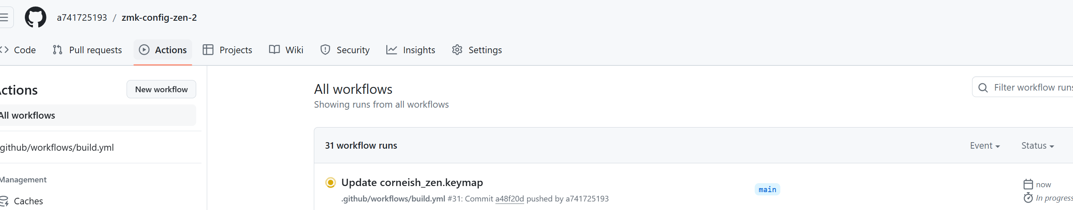

The yellow dots in the above figure indicate that the compilation is in progress. As mentioned earlier, a green √ indicates that the compilation is complete. Simply download the new firmware using the method described earlier. If the red X is not displayed after compilation, it indicates that there is a problem with the firmware modification and compilation has failed. At this point, the simplest way to investigate the cause is to delete your own repo and fork the original configuration library I provided again.Using keymap_iditor can reduce the occurrence of errors.

How to change the config of your keyboard
I do not recommend users to modify keyboard configs, as it is easy to make mistakes.If modifications are needed, you can enter the keyboardnane.conf file.You can turn off keyboard sleep and turn off the keyboard screen. Other functions need to be modified after checking the ZMK official website.
CONFIG_ZMK_DISPLAY=n disabled the display
CONFIG_ZMK_SLEEP=n disabled sleep
Turning off sleep for Mac users can reduce the occurrence of connection errors

How to use the keymap_editor
Modify the keymap file to obtain the new firmware. So we can use this tool to directly modify the keymap file in the specified project. Because this tool is graphical, it can reduce the occurrence of errors.The prerequisite for using it is that you have your own GitHub account and have forked the repo corresponding to your keyboard.
- Log in to the keymap_iditor website, authorize it to access your GitHub account, and select the project that needs to be modified with this tool
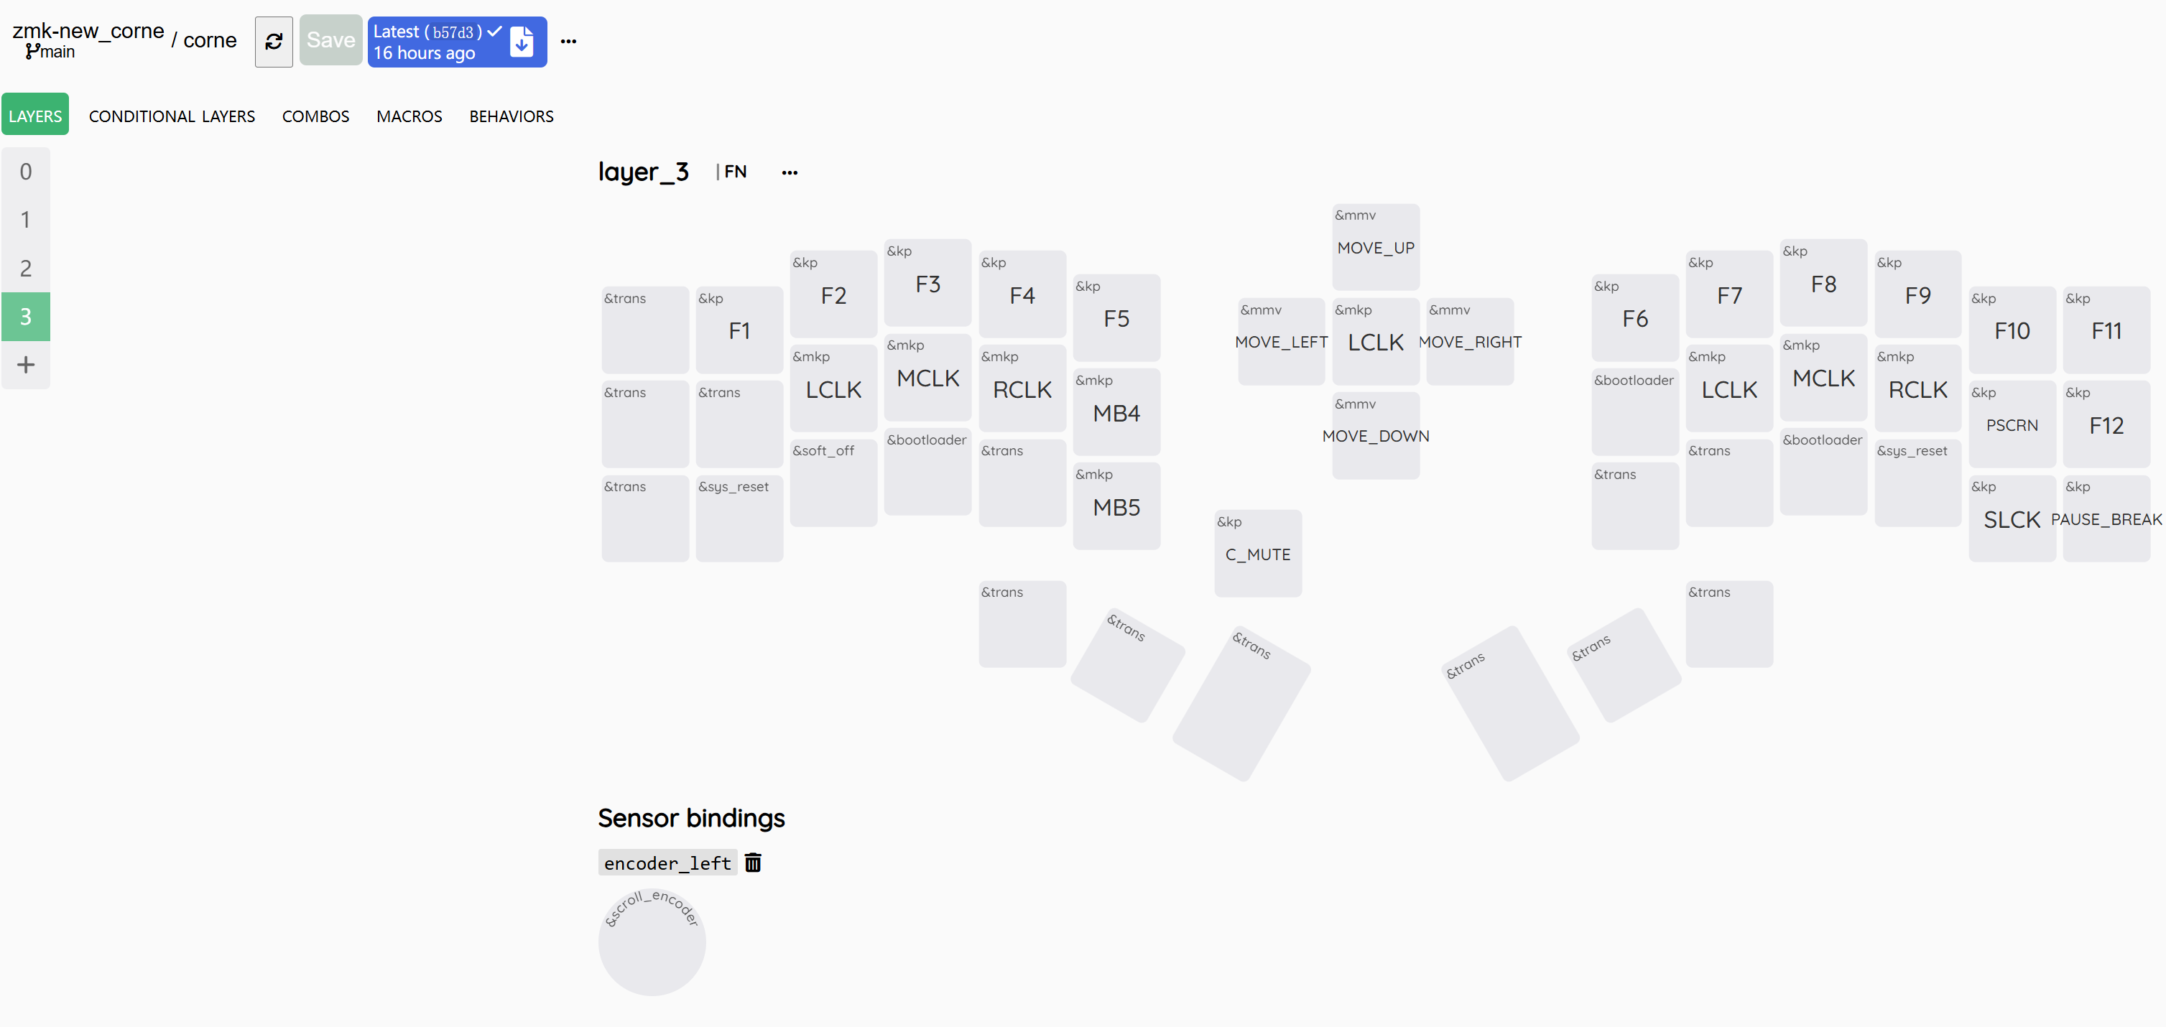

Here，I think you can use it simply. Remember to click save after finishing editing. After clicking save, the git action function will be automatically triggered. Then you can go to git action page to download the new firmware .
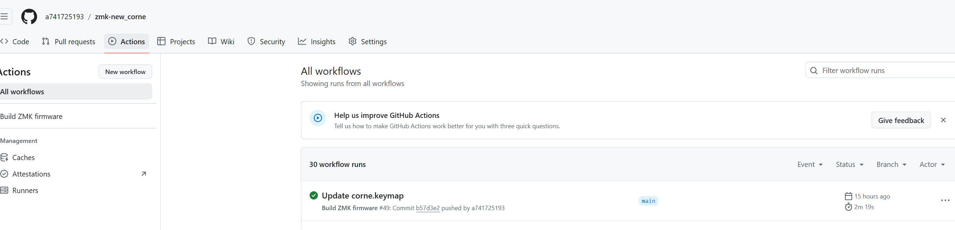
Finally, flash it into your keyboard.

